SSIS
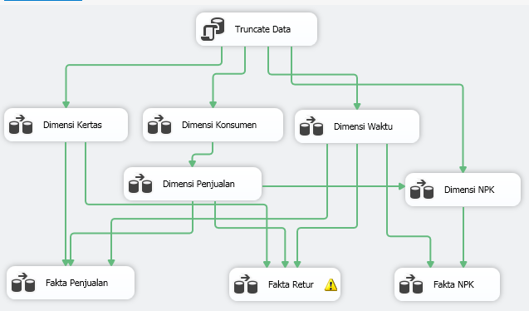
- Dimensi kertas
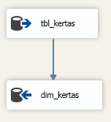
- Dimensi konsumen
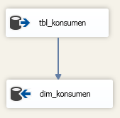
- Dimensi npk
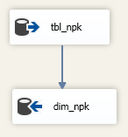
- Dimensi Penjualan
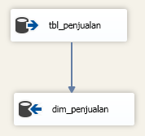
- Dimensi waktu
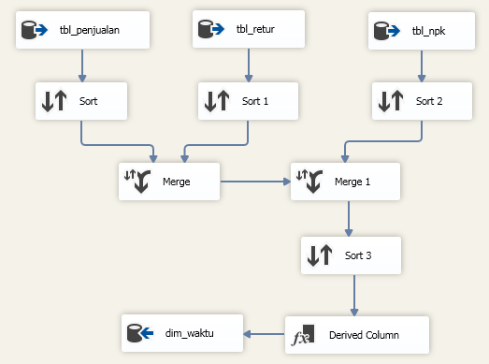
- Fakta npk
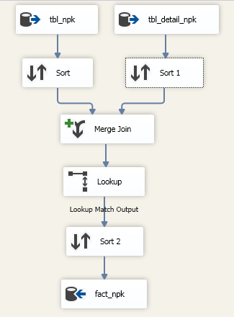
- Fakta penjualan
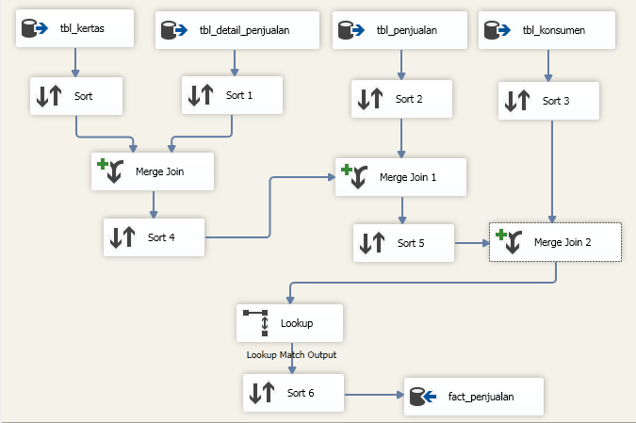
- Fakta retur
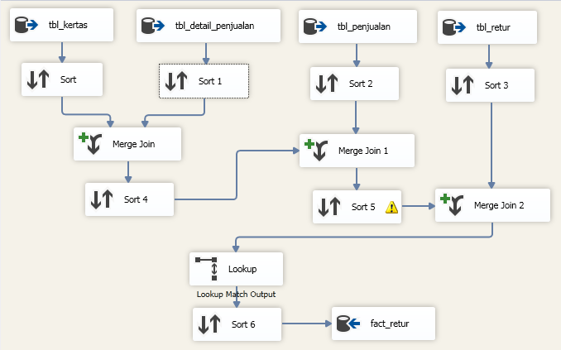

OLAP
- Db Kertas Dm Penjualan.cube
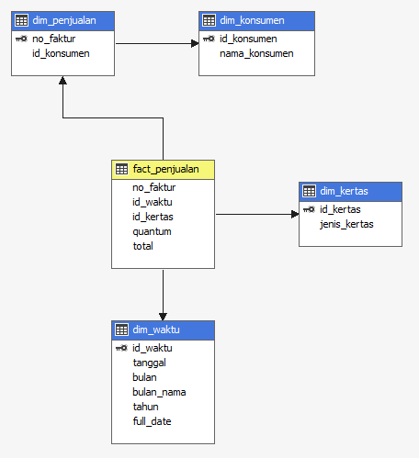
- Db Kertas Dm Retur.cube
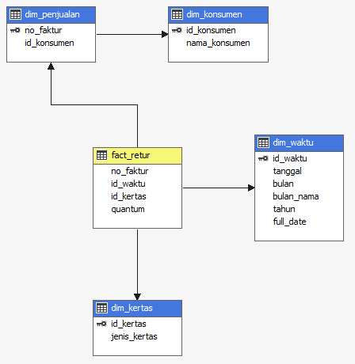
- Db Kertas Dm NPK.cube
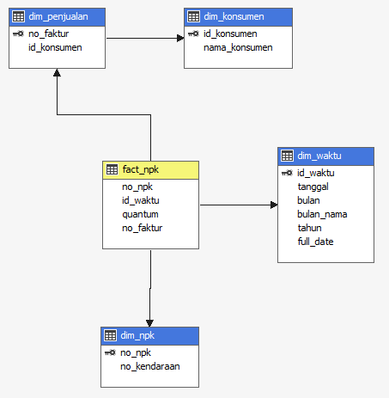

LISTING PROGRAM
Program.cs
using System;
using System.Collections.Generic;
using System.Linq;
using System.Windows.Forms;
using DevExpress.UserSkins;
using DevExpress.Skins;
using DevExpress.LookAndFeel;

namespace DMKilaf
{
static class Program
{
/// <summary>
/// The main entry point for the application.
/// </summary>
[STAThread]
static void Main()
{
Application.EnableVisualStyles();
Application.SetCompatibleTextRenderingDefault(false);

BonusSkins.Register();
SkinManager.EnableFormSkins();
UserLookAndFeel.Default.SetSkinStyle("DevExpress Style");
Application.Run(new FormDataMart());
}
}
}

FormDataMart.cs
using DevExpress.XtraPrinting;
using Microsoft.SqlServer.Dts.Runtime;
using System;
using System.Collections.Generic;
using System.ComponentModel;
using System.Data;
using System.Data.SqlClient;
using System.Drawing;
using System.Linq;
using System.Text;
using System.Windows.Forms;

namespace DMKilaf
{
public partial class FormDataMart : DevExpress.XtraEditors.XtraForm
{
public FormDataMart()
{
InitializeComponent();
}

//========== TAMPIL DATA DIMENSI DAN FAKTA ==========
void DimWaktu()
{
string connection_string = @"Data Source = IHSAN-PC; Initial Catalog = db_kertas_dm; Integrated Security = True";
SqlConnection koneksi = new SqlConnection(connection_string);
koneksi.Open();
string query = "SELECT id_waktu AS 'ID', tanggal AS 'TANGGAL', bulan_nama AS 'BULAN', tahun AS 'TAHUN', full_date AS 'DATE' FROM dim_waktu";
SqlCommand cmd = new SqlCommand(query, koneksi);
SqlDataAdapter sda = new SqlDataAdapter(cmd);
DataTable dt = new DataTable();
sda.Fill(dt);
koneksi.Close();
gridDimWaktu.DataSource = dt;
}

void DimKertas()
{
string connection_string = @"Data Source = IHSAN-PC; Initial Catalog = db_kertas_dm; Integrated Security = True";
SqlConnection koneksi = new SqlConnection(connection_string);
koneksi.Open();
string query = "SELECT id_kertas AS 'ID', jenis_kertas AS 'JENIS KERTAS' FROM dim_kertas";
SqlCommand cmd = new SqlCommand(query, koneksi);
SqlDataAdapter sda = new SqlDataAdapter(cmd);
DataTable dt = new DataTable();
sda.Fill(dt);
koneksi.Close();
gridDimKertas.DataSource = dt;
}

void DimKonsumen()
{
string connection_string = @"Data Source = IHSAN-PC; Initial Catalog = db_kertas_dm; Integrated Security = True";
SqlConnection koneksi = new SqlConnection(connection_string);
koneksi.Open();
string query = "SELECT id_konsumen AS 'ID', nama_konsumen AS 'NAMA KONSUMEN' FROM dim_konsumen";
SqlCommand cmd = new SqlCommand(query, koneksi);
SqlDataAdapter sda = new SqlDataAdapter(cmd);
DataTable dt = new DataTable();
sda.Fill(dt);
koneksi.Close();
gridDimKonsumen.DataSource = dt;
}

void DimPenjualan()
{
string connection_string = @"Data Source = IHSAN-PC; Initial Catalog = db_kertas_dm; Integrated Security = True";
SqlConnection koneksi = new SqlConnection(connection_string);
koneksi.Open();
string query = "SELECT no_faktur AS 'NO FAKTUR', nama_konsumen AS 'KONSUMEN' FROM dim_penjualan p JOIN dim_konsumen k ON p.id_konsumen=k.id_konsumen";
SqlCommand cmd = new SqlCommand(query, koneksi);
SqlDataAdapter sda = new SqlDataAdapter(cmd);
DataTable dt = new DataTable();
sda.Fill(dt);
koneksi.Close();
gridDimPenjualan.DataSource = dt;
}

void FactPenjualan()
{
string connection_string = @"Data Source = IHSAN-PC; Initial Catalog = db_kertas_dm; Integrated Security = True";
SqlConnection koneksi = new SqlConnection(connection_string);
koneksi.Open();
string query = "SELECT p.no_faktur AS 'NO FAKTUR', k.jenis_kertas AS 'JENIS KERTAS', w.tanggal AS 'TANGGAL', w.bulan_nama AS 'BULAN', w.tahun AS 'TAHUN', p.quantum AS 'QUANTUM', p.total AS 'TOTAL' FROM fact_penjualan p JOIN dim_kertas k ON p.id_kertas=k.id_kertas JOIN dim_waktu w ON p.id_waktu=w.id_waktu";
SqlCommand cmd = new SqlCommand(query, koneksi);
SqlDataAdapter sda = new SqlDataAdapter(cmd);
DataTable dt = new DataTable();
sda.Fill(dt);
koneksi.Close();
gridFact_penjualan.DataSource = dt;
}

void FactRetur()
{
string connection_string = @"Data Source = IHSAN-PC; Initial Catalog = db_kertas_dm; Integrated Security = True";
SqlConnection koneksi = new SqlConnection(connection_string);
koneksi.Open();
string query = "SELECT r.no_faktur AS 'NO FAKTUR', k.jenis_kertas AS 'JENIS KERTAS', w.tanggal AS 'TANGGAL', w.bulan_nama AS 'BULAN', w.tahun AS 'TAHUN', SUM(r.quantum) AS 'QUANTUM' FROM fact_retur r JOIN dim_waktu w ON r.id_waktu=w.id_waktu JOIN dim_kertas k ON r.id_kertas=k.id_kertas GROUP BY r.no_faktur, k.jenis_kertas, w.tanggal, w.bulan_nama, w.tahun";
SqlCommand cmd = new SqlCommand(query, koneksi);
SqlDataAdapter sda = new SqlDataAdapter(cmd);
DataTable dt = new DataTable();
sda.Fill(dt);
koneksi.Close();
gridFactRetur.DataSource = dt;
}
//========== END TAMPIL DATA DIMENSI DAN FAKTA ==========

//========== ETL UPDATE DATA MART ==========
private void btnUpdateETL_Click(object sender, EventArgs e)
{
try
{
splashScreenManager1.ShowWaitForm();
Cursor.Current = Cursors.WaitCursor;
string lokasi = Environment.CurrentDirectory.ToString() + "\\Resources\\Package.dtsx";
DTSExecResult pkgResults_Sql;
Microsoft.SqlServer.Dts.Runtime.Application app = new Microsoft.SqlServer.Dts.Runtime.Application();
Microsoft.SqlServer.Dts.Runtime.Package pkg = new Microsoft.SqlServer.Dts.Runtime.Package();
pkg = app.LoadPackage(lokasi, null);
pkgResults_Sql = pkg.Execute();
splashScreenManager1.CloseWaitForm();
MessageBox.Show("Data berhasil di-Update.", "Pesan", MessageBoxButtons.OK, MessageBoxIcon.Information);
TampilData();
}
catch (System.Exception f)
{
MessageBox.Show(f.Message);
}
finally
{
Cursor.Current = Cursors.Default;
}
}
//========== END ETL UPDATE DATA MART ==========

//========== ANALISIS DATA PENJUALAN ==========
private void btnPivotPenjualan_Click(object sender, EventArgs e)
{
pivotGridOlapPenjualan.Visible = true;
chartOlapPenjualan.Visible = false;
}

private void btnGrafikPenjualan_Click(object sender, EventArgs e)
{
pivotGridOlapPenjualan.Visible = false;
chartOlapPenjualan.Visible = true;
}

private void btnCetakPenjualan_Click(object sender, EventArgs e)
{
PrintableComponentLink link = new PrintableComponentLink(new PrintingSystem());
link.Component = pivotGridOlapPenjualan;
link.CreateMarginalHeaderArea += new CreateAreaEventHandler(Link_CreateMarginalHeaderAreaPenjualan);
link.CreateMarginalFooterArea += new CreateAreaEventHandler(Link_CreateMarginalFooterAreaPenjualan);
link.CreateReportHeaderArea += new CreateAreaEventHandler(Link_CreateReportHeaderAreaPenjualan);
link.CreateDocument();
link.ShowPreview();
}

private void Link_CreateReportHeaderAreaPenjualan(object sender, CreateAreaEventArgs e)
{
string reportHeader = "Data Penjualan Kertas";
e.Graph.StringFormat = new BrickStringFormat(StringAlignment.Center);
e.Graph.Font = new Font("Time News Roman", 14, FontStyle.Bold);
RectangleF rec = new RectangleF(0, 0, e.Graph.ClientPageSize.Width, 40);
e.Graph.DrawString(reportHeader, Color.Black, rec, BorderSide.None);
}

private void Link_CreateMarginalFooterAreaPenjualan(object sender, CreateAreaEventArgs e)
{
PageInfoBrick brick = e.Graph.DrawPageInfo(PageInfo.None, "KERTAS PADALARANG", Color.Black, new RectangleF(0, 0, 500, 40), BorderSide.None);
brick.LineAlignment = BrickAlignment.Center;
brick.Alignment = BrickAlignment.Far;
brick.AutoWidth = true;
brick.Font = new Font("Time News Roman", 10);
}

private void Link_CreateMarginalHeaderAreaPenjualan(object sender, CreateAreaEventArgs e)
{
PageInfoBrick brick = e.Graph.DrawPageInfo(PageInfo.None, "KERTAS PADALARANG", Color.Black, new RectangleF(0, 0, 500, 40), BorderSide.None);
brick.Alignment = BrickAlignment.Near;
brick.AutoWidth = true;
brick.Font = new Font("Time News Roman", 16, FontStyle.Bold);
}
//========== END ANALISIS DATA PENJUALAN ==========

//========== ANALISIS DATA PENDAPATAN ==========
private void btnPivotPendapatan_Click(object sender, EventArgs e)
{
pivotGridOlapPendapatan.Visible = true;
chartOlapPendapatan.Visible = false;
}

private void btnGrafikPendapatan_Click(object sender, EventArgs e)
{
pivotGridOlapPendapatan.Visible = false;
chartOlapPendapatan.Visible = true;
}

private void btnCetakPendapatan_Click(object sender, EventArgs e)
{
PrintableComponentLink link = new PrintableComponentLink(new PrintingSystem());
link.Component = pivotGridOlapPendapatan;
link.CreateMarginalHeaderArea += new CreateAreaEventHandler(Link_CreateMarginalHeaderAreaPendapatan);
link.CreateMarginalFooterArea += new CreateAreaEventHandler(Link_CreateMarginalFooterAreaPendapatan);
link.CreateReportHeaderArea += new CreateAreaEventHandler(Link_CreateReportHeaderAreaPendapatan);
link.CreateDocument();
link.ShowPreview();
}

private void Link_CreateReportHeaderAreaPendapatan(object sender, CreateAreaEventArgs e)
{
string reportHeader = "Data Pendapatan Penjualan";
e.Graph.StringFormat = new BrickStringFormat(StringAlignment.Center);
e.Graph.Font = new Font("Time News Roman", 14, FontStyle.Bold);
RectangleF rec = new RectangleF(0, 0, e.Graph.ClientPageSize.Width, 40);
e.Graph.DrawString(reportHeader, Color.Black, rec, BorderSide.None);
}

private void Link_CreateMarginalFooterAreaPendapatan(object sender, CreateAreaEventArgs e)
{
PageInfoBrick brick = e.Graph.DrawPageInfo(PageInfo.None, "KERTAS PADALARSNG", Color.Black, new RectangleF(0, 0, 500, 40), BorderSide.None);
brick.LineAlignment = BrickAlignment.Center;
brick.Alignment = BrickAlignment.Far;
brick.AutoWidth = true;
brick.Font = new Font("Time News Roman", 10);
}

private void Link_CreateMarginalHeaderAreaPendapatan(object sender, CreateAreaEventArgs e)
{
PageInfoBrick brick = e.Graph.DrawPageInfo(PageInfo.None, "KERTAS PADALARANG", Color.Black, new RectangleF(0, 0, 500, 40), BorderSide.None);
brick.Alignment = BrickAlignment.Near;
brick.AutoWidth = true;
brick.Font = new Font("Time News Roman", 16, FontStyle.Bold);
}
//========== END ANALISIS DATA PENDAPATAN ==========

//========== END ANALISIS DATA RETUR ==========
private void btnPivotRetur_Click(object sender, EventArgs e)
{
pivotGridOlapRetur.Visible = true;
chartOlapRetur.Visible = false;
}

private void btnGrafikRetur_Click(object sender, EventArgs e)
{
pivotGridOlapRetur.Visible = false;
chartOlapRetur.Visible = true;
}

private void btnCetakRetur_Click(object sender, EventArgs e)
{
PrintableComponentLink link = new PrintableComponentLink(new PrintingSystem());
link.Component = pivotGridOlapRetur;
link.CreateMarginalHeaderArea += new CreateAreaEventHandler(Link_CreateMarginalHeaderAreaRetur);
link.CreateMarginalFooterArea += new CreateAreaEventHandler(Link_CreateMarginalFooterAreaRetur);
link.CreateReportHeaderArea += new CreateAreaEventHandler(Link_CreateReportHeaderAreaRetur);
link.CreateDocument();
link.ShowPreview();
}

private void Link_CreateReportHeaderAreaRetur(object sender, CreateAreaEventArgs e)
{
string reportHeader = "Data Retur Penjualan";
e.Graph.StringFormat = new BrickStringFormat(StringAlignment.Center);
e.Graph.Font = new Font("Time News Roman", 14, FontStyle.Bold);
RectangleF rec = new RectangleF(0, 0, e.Graph.ClientPageSize.Width, 40);
e.Graph.DrawString(reportHeader, Color.Black, rec, BorderSide.None);
}

private void Link_CreateMarginalFooterAreaRetur(object sender, CreateAreaEventArgs e)
{
PageInfoBrick brick = e.Graph.DrawPageInfo(PageInfo.None, "KERTAS PADALARANG", Color.Black, new RectangleF(0, 0, 500, 40), BorderSide.None);
brick.LineAlignment = BrickAlignment.Center;
brick.Alignment = BrickAlignment.Far;
brick.AutoWidth = true;
brick.Font = new Font("Time News Roman", 10);
}

private void Link_CreateMarginalHeaderAreaRetur(object sender, CreateAreaEventArgs e)
{
PageInfoBrick brick = e.Graph.DrawPageInfo(PageInfo.None, "KERTAS PADALARANG", Color.Black, new RectangleF(0, 0, 500, 40), BorderSide.None);
brick.Alignment = BrickAlignment.Near;
brick.AutoWidth = true;
brick.Font = new Font("Time News Roman", 16, FontStyle.Bold);
}
//========== END ANALISIS DATA RETUR ==========

//========== LOGIN ==========
private void btnLogin_Click(object sender, EventArgs e)
{
string username = "manajer";
string password = "manajer";
if (textUsername.Text == username && textPassword.Text == password)
{
panelLogin.Visible = false;
tabDataMart.Visible = true;
}
else
{
MessageBox.Show("Username atau Password salah.");
}
}

private void btnReset_Click(object sender, EventArgs e)
{
textUsername.Text = "";
textPassword.Text = "";
}
//========== END LOGIN ==========

//========== TAMPIL DATA ==========
void TampilData()
{
string connection_string = @"Data Source = IHSAN-PC; Initial Catalog = db_kertas_dm; Integrated Security = True";
SqlConnection koneksi = new SqlConnection(connection_string);
koneksi.Open();
string query = "SELECT * FROM dim_waktu";
SqlCommand cmd = new SqlCommand(query, koneksi);
SqlDataAdapter sda = new SqlDataAdapter(cmd);
DataTable dt = new DataTable();
sda.Fill(dt);
koneksi.Close();

if (dt.Rows.Count == 0)
{
labelHome.Visible = false;

xtraTabControl3.Visible = false;
labelLihatData.Visible = true;

xtraTabControl2.Visible = false;
labelAnalisis.Visible = true;
}
else
{
labelHome.Visible = true;

xtraTabControl3.Visible = true;
labelLihatData.Visible = false;

xtraTabControl2.Visible = true;
labelAnalisis.Visible = false;

DimWaktu();
DimKertas();
DimKonsumen();
DimPenjualan();
FactPenjualan();
FactRetur();
}
}
//========== END TAMPIL DATA ==========

//========== FORM LOAD ==========
private void FormDataMart_Load(object sender, EventArgs e)
{
TampilData();
panelLogin.Visible = true;
tabDataMart.Visible = false;

labelAnalisis.Visible = false;
labelLihatData.Visible = false;
}
}
}

WaitForm1.cs
using System;
using System.Collections.Generic;
using System.ComponentModel;
using System.Data;
using System.Drawing;
using System.Text;
using System.Windows.Forms;
using DevExpress.XtraWaitForm;

namespace DMKilaf
{
public partial class WaitForm1 : WaitForm
{
public WaitForm1()
{
InitializeComponent();
this.progressPanel1.AutoHeight = true;
}

#region Overrides

public override void SetCaption(string caption)
{
base.SetCaption(caption);
this.progressPanel1.Caption = caption;
}
public override void SetDescription(string description)
{
base.SetDescription(description);
this.progressPanel1.Description = description;
}
public override void ProcessCommand(Enum cmd, object arg)
{
base.ProcessCommand(cmd, arg);
}

#endregion

public enum WaitFormCommand
{
}
}
}

App.config
<?xml version="1.0" encoding="utf-8" ?>
<configuration>
<startup useLegacyV2RuntimeActivationPolicy="true">
<supportedRuntime version="v4.0" sku=".NETFramework,Version=v4.5" />
</startup>
</configuration>

ANTARMUKA
- Login
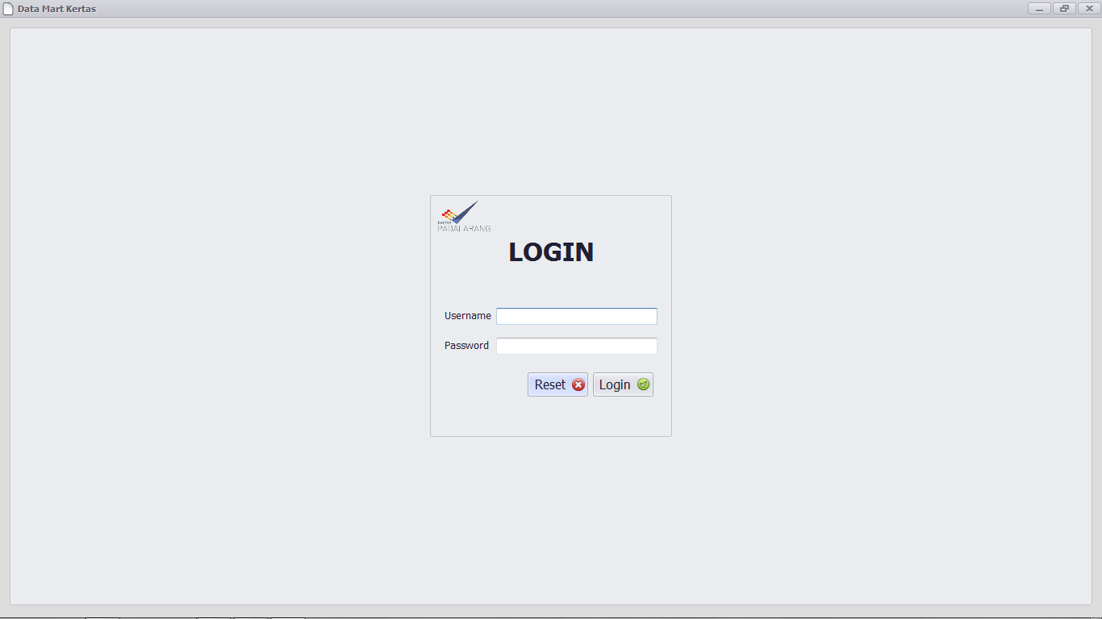
- Halaman utama
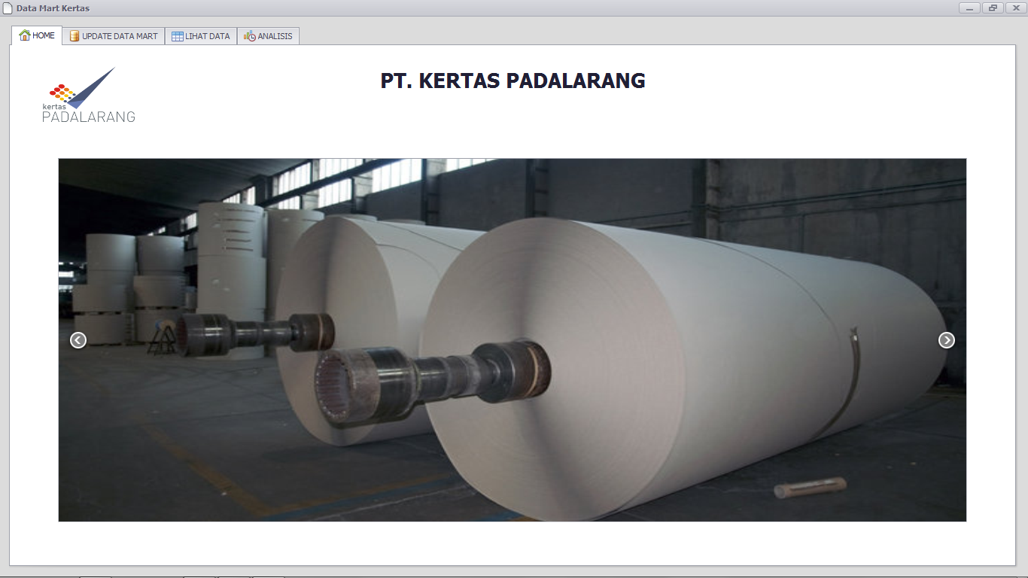
- Update datamart
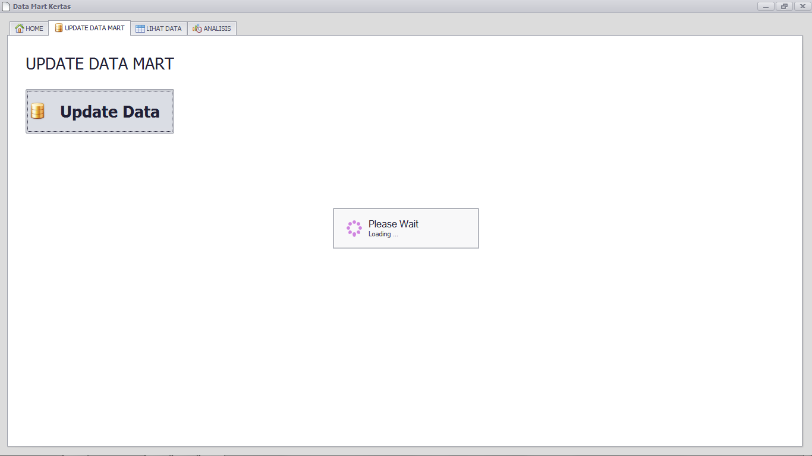
- Lihat datamart
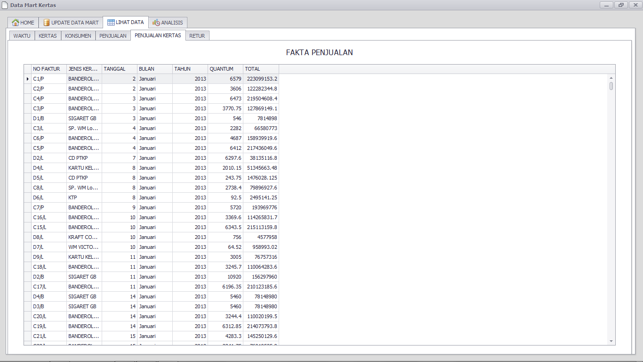
- Pivot
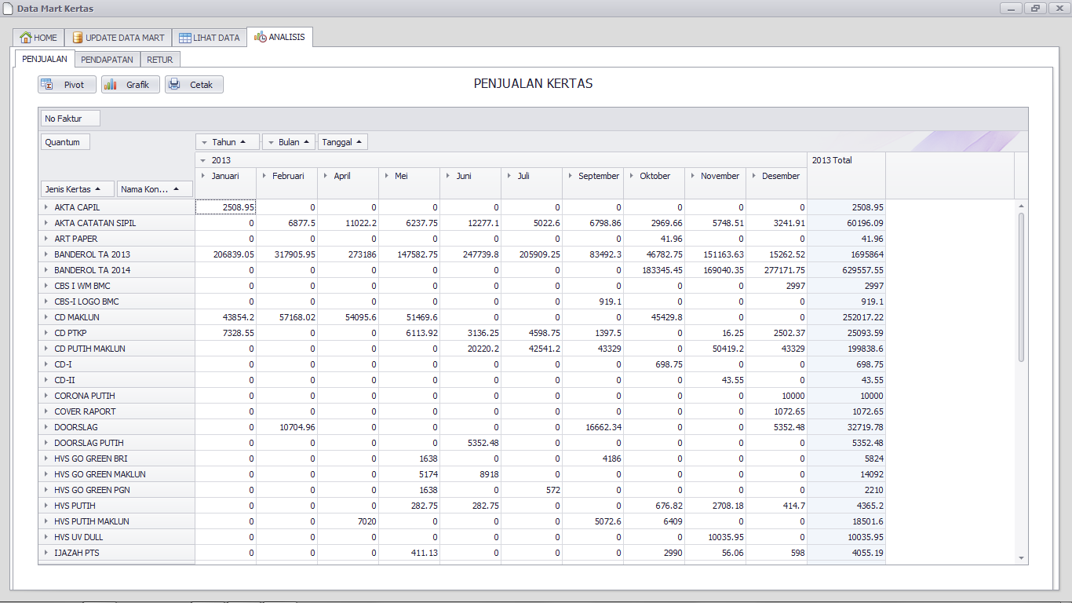
- Chart
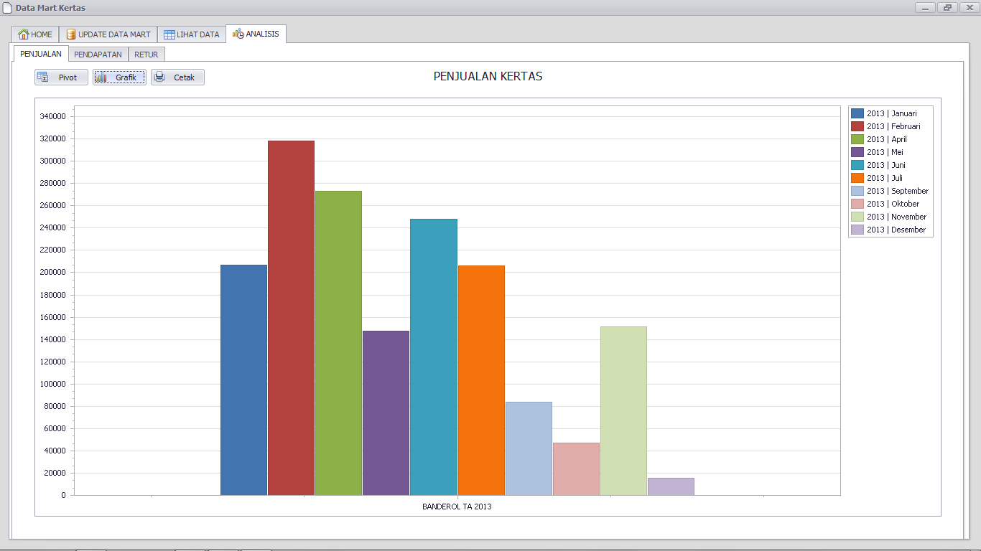
- Cetak laporan
